Practical - 14
Practical Title: Admin Dashboard with Role-Based Access Control, Dynamic Menu, and Audit Log

Problem Definition : Develop an admin dashboard that displays user statistics, student count, event count and latest registrations. Restrict access to admin users only and show dynamic menu options based on role.

Theory
1. Are dashboard values loaded dynamically from the database?
Yes, dashboard values such as total users, students, and events are loaded dynamically from the MySQL database.

2. Is access restricted to admin users?
Yes, only users with the admin role can access the Admin Dashboard. Unauthorized users are redirected to another page.

3. Are role-based menus working?
Yes, different menu options are provided for admin and student users according to their roles.

4. Are important admin actions recorded in audit_logs?
Yes, admin activities such as viewing the Admin Dashboard are recorded in the audit_logs table with the username, action, and date and time.

A. Evidence of Work (Screenshots):
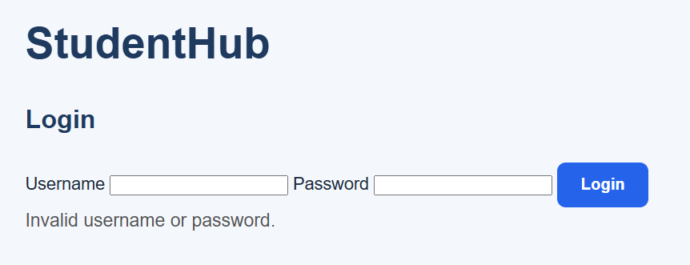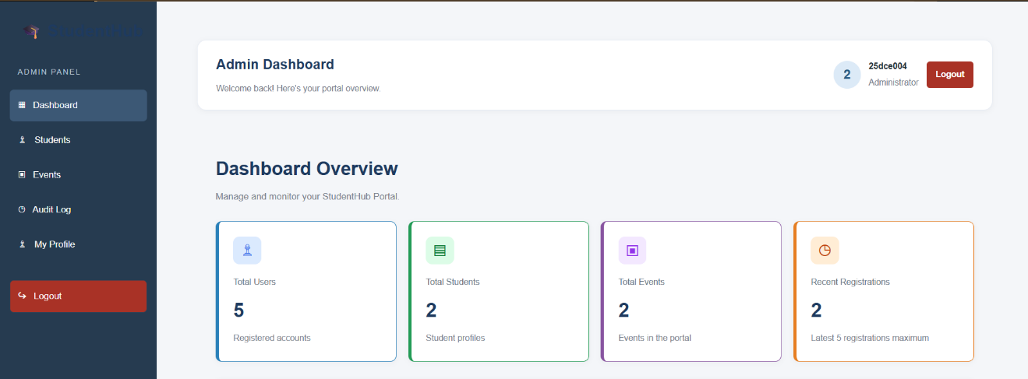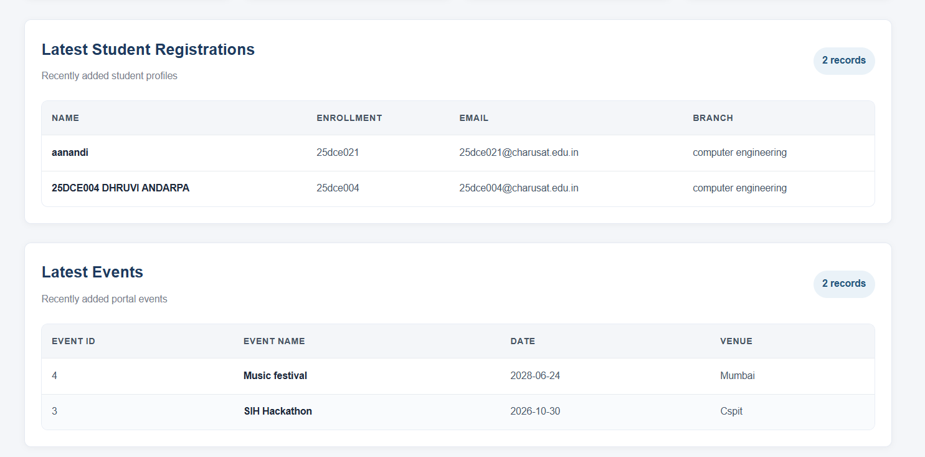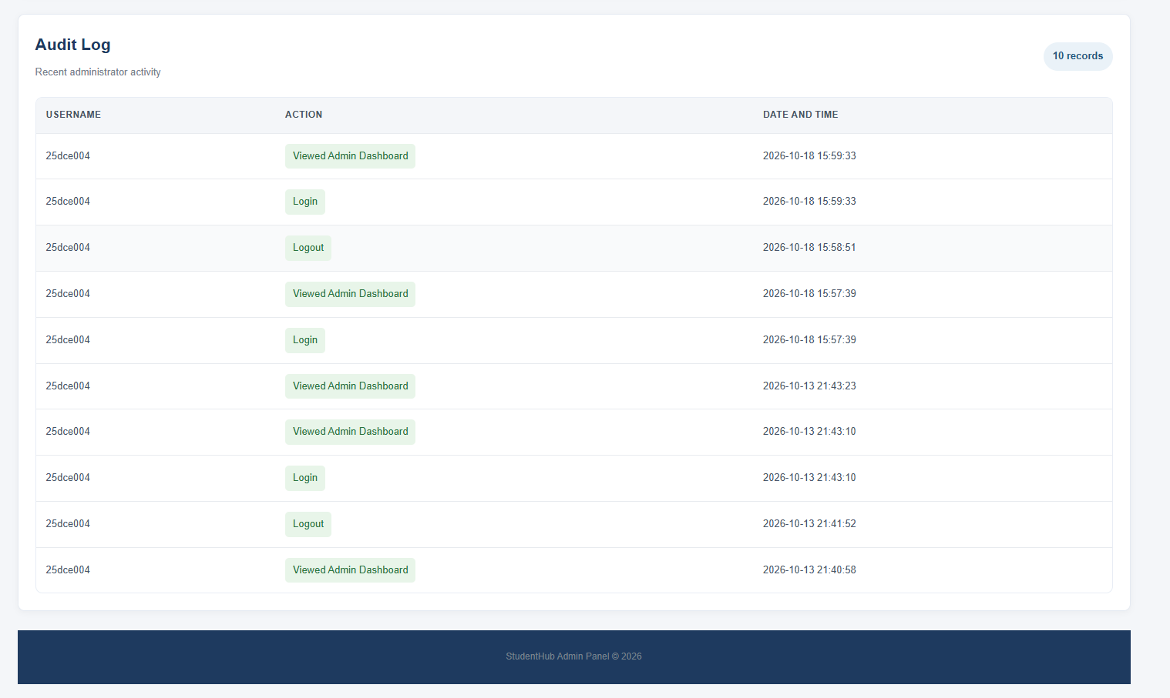
B.GitHub Repository Link:
https://github.com/Andarpadhruvi1125/Student-Hub-portal.git
C. Challenges Faced
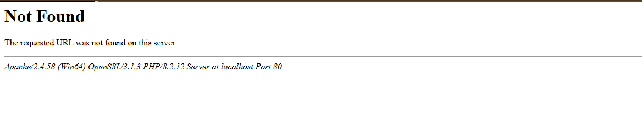
The main challenges faced in this practical were connecting the admin dashboard with the MySQL database, displaying user, student, and event counts dynamically, restricting dashboard access based on user roles, and recording admin activities in the audit_logs table.
D.Learning Outcomes:
I learned how to create a dynamic admin dashboard using PHP and MySQL, implement role-based access control, display the latest student registrations and events, and maintain an audit log to track important admin activities.
Faculty Remarks:

